

**SITE INTERFACING WITH THE DATABASE**

PROGRAM: BACHELOR’S IN COMPUTER SCIENCE

NAME: MUHAMMAD SAAD 2112118

SUBMISSION DATE: January 2022

ACKNOWLEDMENT

We would like to express our sincere gratitude to several individuals an organizations for supporting us throughout our 1st semester. First, We wish to express our sincere gratitude to our supervisor, Sadia Aziz and Khalil-ur-Rehman for their enthusiasm, patience, insightful comments, helpful information, practical advice, and unceasing ideas that have helped us tremendously at all times in our research. Their immense knowledge, profound experience and professional expertise in this project has enabled us to complete this research successfully. Without their support and guidance, this project would not have been possible. I could not have imagined having a better supervisor in my study.

ABSTRACT

This project is based on how you can transfer your data from any website to the server database. In this project, we used HTML, CSS, and PHP. It’s not just a static website but it is connected to the database where you can see all the information you submitted. This project is useful when the student is enrolling online in the university, so the university can track the student's credentials.

TABLE OF CONTENT

|  |  |  |
| --- | --- | --- |
| S.NO | CHAPTERS | PAGE NO. |
| 1. | Introduction | 5 |
| 2. | Background | 6 |
| 3. | Working of project | SS |
| 4. | Scope of project | 7 |
| 5. | Conclusion | 7 |

INTRODUCTION

Our website is organized by tabs or other form of navigation. Each page can redirect to you on other pages on a new window tab. The main focus of our project is to connect the website with server database where you can access all the information submitted by the users. We use basic HTML tags, inline CSS and a PHP code which is the most essential page to connect your website with database

BACKGROUND

ALGORITHM

1. Start
2. Display webpage
3. Choose from pages

* Admission
* Contact
* Courses
* Pages
* Signup

1. Display pages
2. If page chosen is Sign-up
3. Display Sign-up page
4. Display message “Registration Successful”
5. Then go to MySQL database
6. Access the information
7. End

FLOWCHART

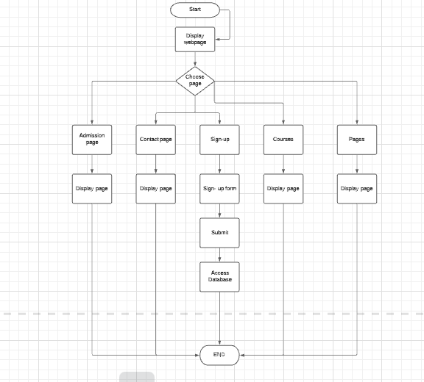

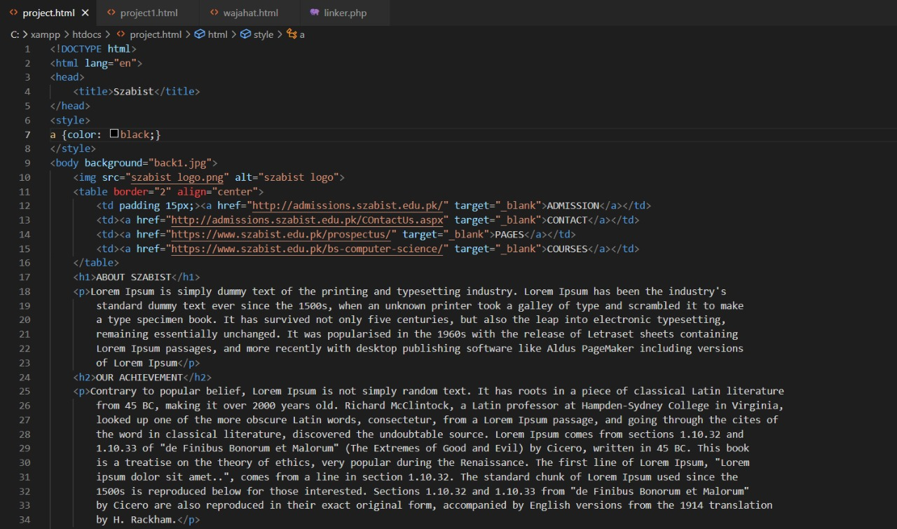 Working of the Project

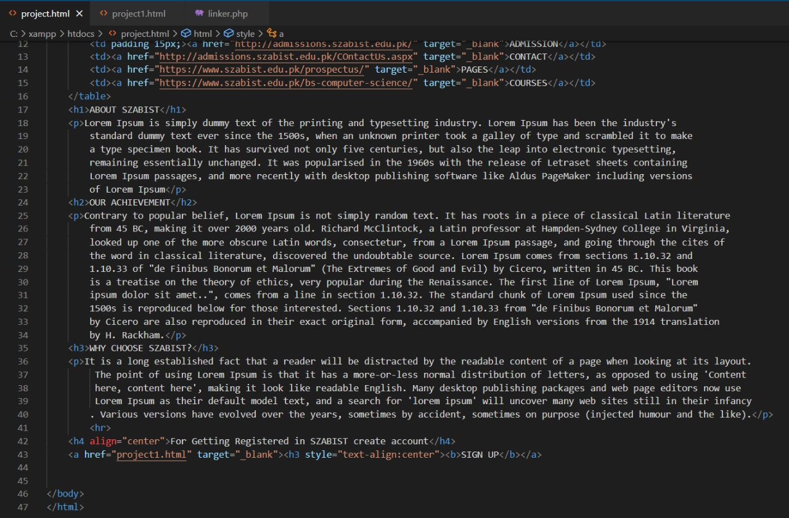

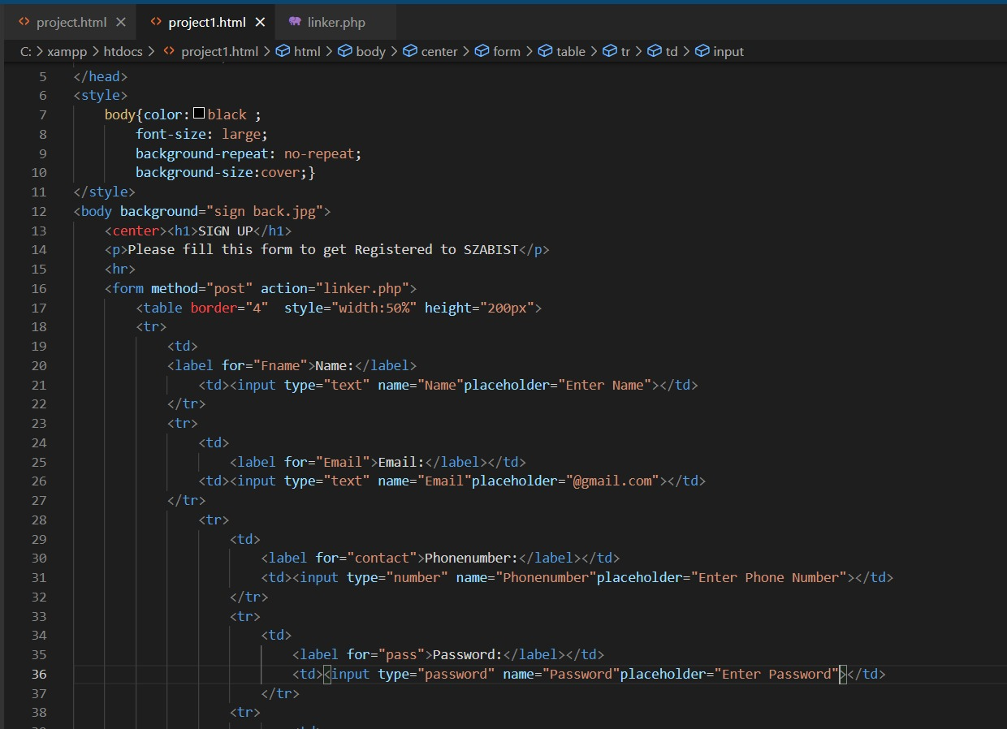

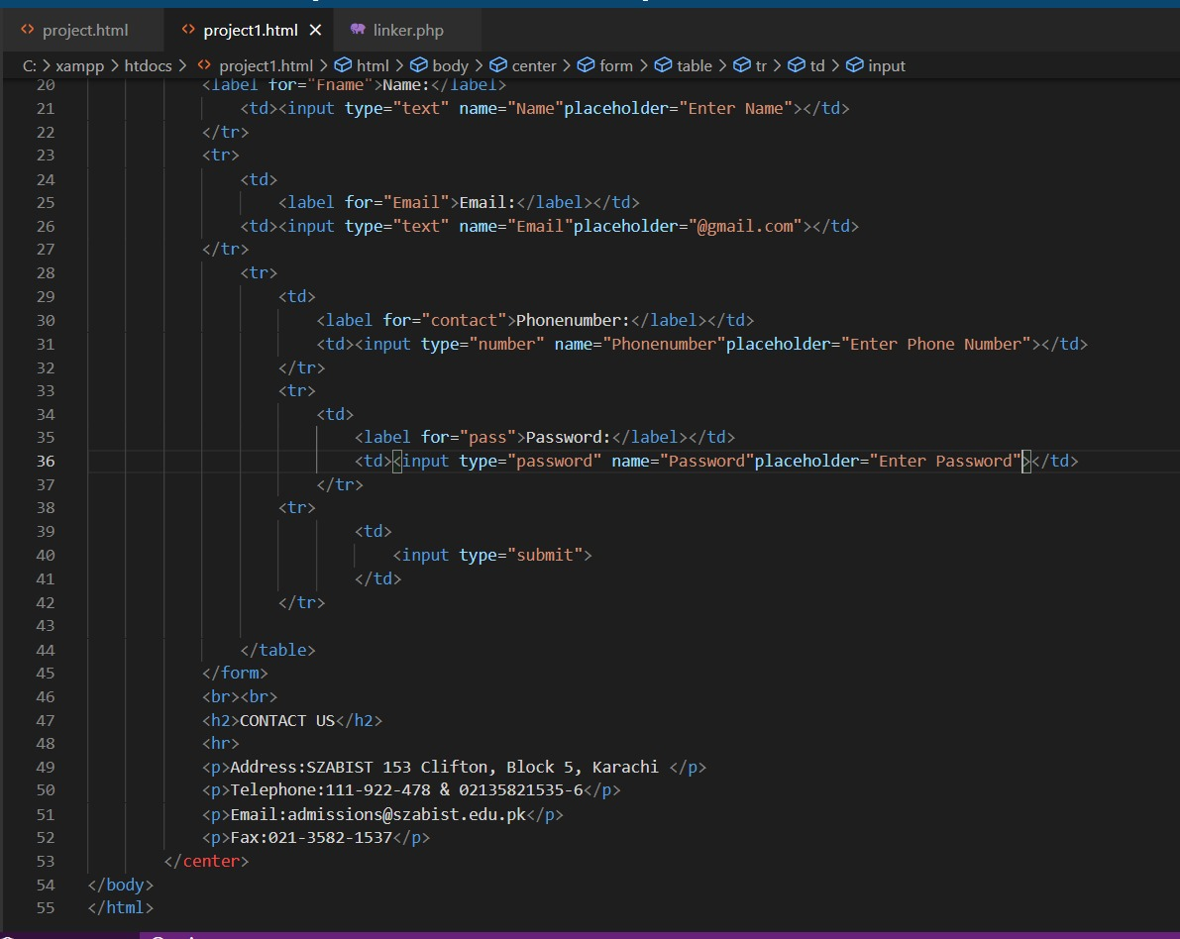

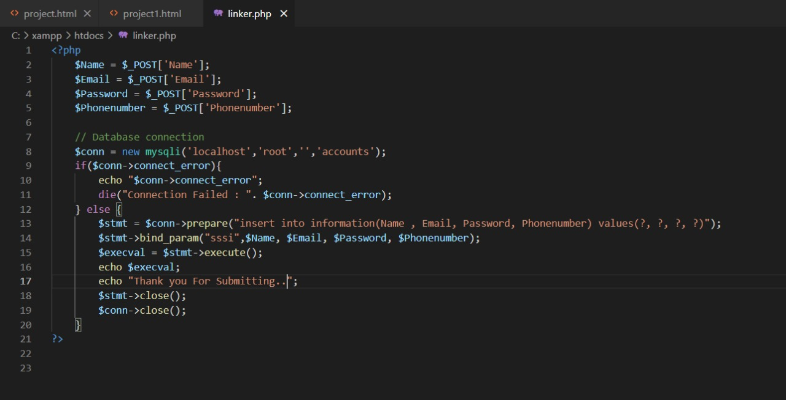

Output

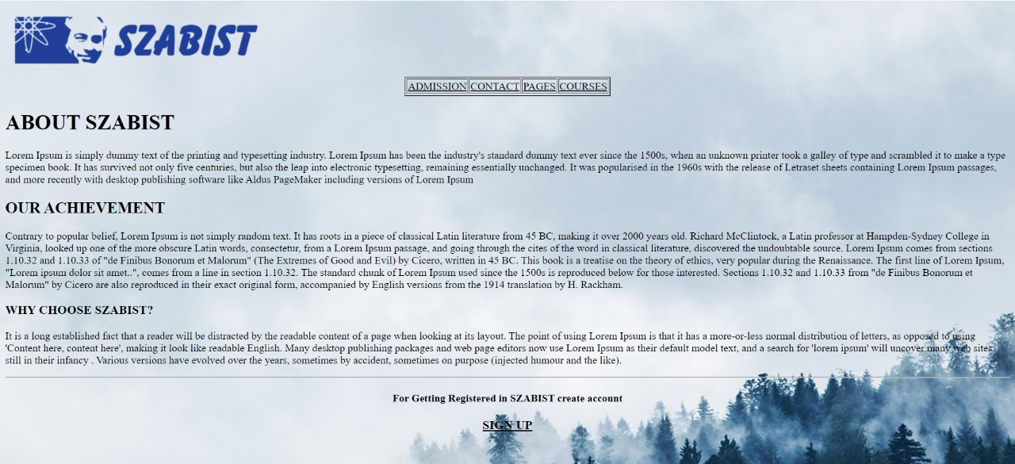

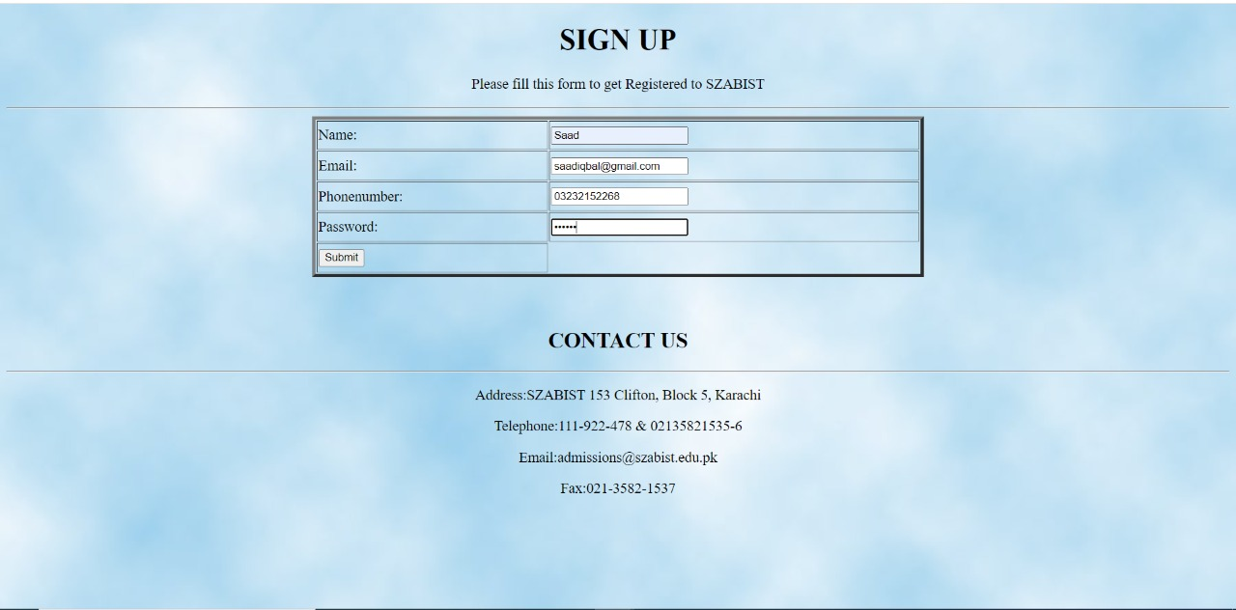



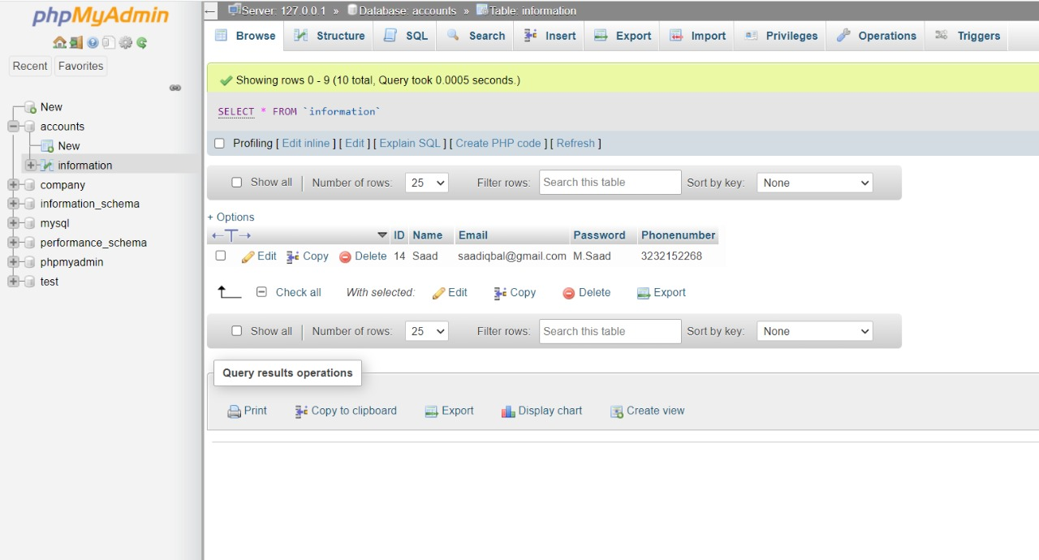

SCOPE OF PROJECT

The scope of this project is to get registered in the university by the website of the university and student share his credentials on the university website by submitting the form. By which university can access the student credentials from the database which he submitted.

CONCLUSION

In the nutshell, we make a website which can interact with the SQL database so you can access information at any time you want.

REFERENCE

* [www.youtube.com](http://www.youtube.com)
* [www.szabist.edu.pk](http://www.szabist.edu.pk)
* Miss’s Sadia slides